Stake and GPS corners of plot with help of map and datasheets.

**Tree measuring:**

* Measure DBH of all adult trees on old map/data sheet, noting whether the tree tag number has changed (use only new number on new map). If it has an old etched tag, replace it and take note of new number.
* If tree doesn’t reach DBH, the datasheet should tell you the height at which it was measured in the past. If the tree is new (older cocos sapling, for example), note the height at which you measured it.
* For all adult trees, record reproductive condition – does it have flowers, immature nuts, mature nuts. Note the number of each in each tree.
* Put new flagging tape on tree.
* Put trees on new map.

**Saplings:**

* A cocos sapling is any coconut seedling that no longer has its seed.
* Walk the entire plot and map out saplings, taking measurements from the base or from where the leaves separate from the trunk.
* Nail a tree tag and put flagging around the base of each sapling.
* Map all saplings on the new map.

**Nuts:**

* Search entire plot and look for labeled nuts from last year. Note the condition of each (never sprouted, rotten, sprouted and died, seedling).
* If a labeled nut has become a seedling, flag and nail in a tree tag, making note of nut number and tree tag number. Map these seedlings on the map.
* Find all new viable mature nuts from this year (still would float, no holes, not ant infested, would sprout if given a chance), and label them with (Island_First_Letter)15(for 2015) – 1, 2, 3… So a Paradise 2015 nut would be labeled P15 -1, Kaula would be K15 – 1, etc. Map these nuts on the map. Also, spraypaint and indicate what color spray paint you use on seeds (different color than seedlings).

**Seedling sub-sample:**

* Using spray paint and a counter, count all cocos seedlings in the plot. If there are more than 150, then you can subsample, and take note of your estimate for the total number for the plot. If there are fewer than 150, label all the seedlings in the plot and map them, if more than 150, follow the following protocol:
* Stake out 4 and 8 meter boundaries on either short end of the plot (image).
* In the sub-plot that is between these two boundaries (swath 4m x 25m), flag and nail tree tags into every seedling. Map these seedlings on the map.
* For Pandanus seedlings, count the total number in the plot and map their general area. If they have woody sections, nail in tags.
* For Pisonia seedlings, nail a tag into all trunks that are rooted. If there are multiple branches coming from one rooted section, count them as one seedling and measure the larger of the two. For places like Whippoorwill with tons of Pisonia seedlings, tag each seedling, and average their DBH size classes. If all are in the same/a similar size class (<5 cm DBH), make note of that. Only take individual DBH on seedlings/saplings with >5 cm DBH.

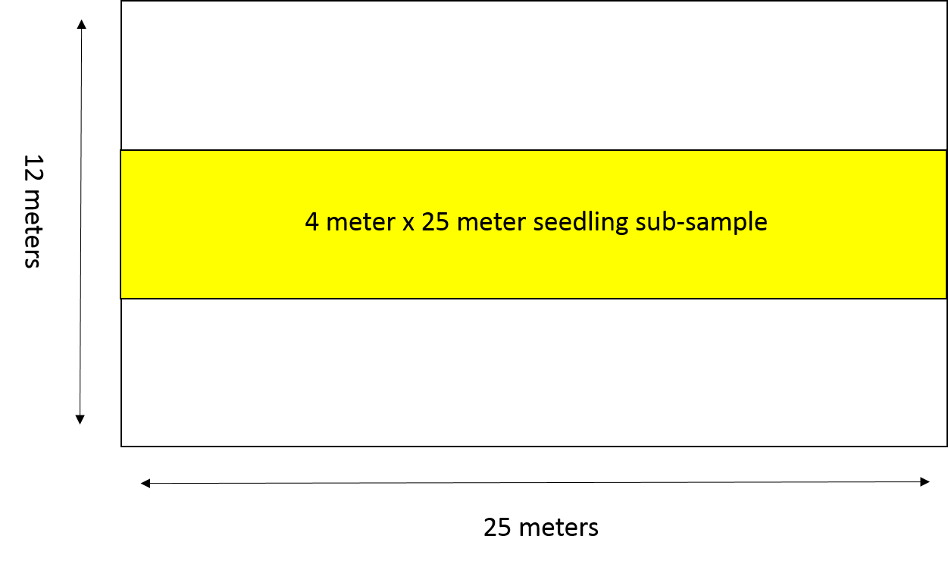

**Quadrats:**

- Quantify Fallen Nuts: At every 5 x 3 m intersection lay a 1x1 m quadrat (24 total quadrats per permanent plot). If the quadrat falls over a live tree trunk, such that ground cover beneath it cannot be measured, move the quadrat to the closest location that does not include a tree

- Count all nuts in the quadrat and put in the following categories.

- Intact mature nut

- Predated mature nut

- Rotted mature nut

- Intact immature nut

- Predated immature nut

- Rotted immature nut

- Sprouted but now dead nut

- Do not count nut debris that is less than 50% of a nut

- If a nut is so decomposed that it cannot be picked up without breaking apart, do not count it as a nut

- Quantify Ground Cover: When you place the fallen nut quadrats (see above) you should also count and record ground cover to the nearest 5%. Categories are as follows.

- Rock or rubble

- Bare ground or sand

- Herbaceous species – specify species (Phymatosaurus. scolopendria, or Laportea. ruderalis, grass)

- Litter (of any species but coconuts)

- Cocos debris (includes fronds, nuts, racimes, etc)

- Live tree of any species – specify species, and count number of that species.

**Maps and Documentation:**

* Take lots of pictures of the plots! Both of the trees, seedlings, groundcover, and of people doing work in them!
* Make a new map with all new and old information in it. The map should include:

1. Date, Location, orientations (where is coast, or where is the NE corner, that sort of thing), legend
2. Adult trees
3. New saplings
4. Seedlings from old nuts
5. New nuts
6. Map of seedlings in plot middle subsection

**Back in the Lab:**

* Enter all the tree, sapling, seedlings, old/new nut, and seedling subplot data into the Permanent Plot Data Sheets 2015 Excel file.
* Enter tree presence or absence (1 or 0 in column) in the Compiled Permanent Plot Data through 2015 Excel file.
* Download all images taken of plot and label them by plot name and year.
* Scan in the map page(s) on the scanner in the TikiLounge. Label these files by plot and page number (Kaula map page 1 of 3, etc).
* Upload all datasheets, images, and maps to the Permanent Plots 2015 Dropbox folder.

**Tips:**

|  |
| --- |
| For the person doing anything but trees, map out seedlings, saplings, nuts, etc. in relation to trees - it makes it easier for the tree person putting together the whole map.  Bring camera to take possible pictures of tree tags; sometimes there is flagging, but other times the tags are up high on *Pandanus* (don’t attempt to climb – you will regret it).  The best paint pens to use when marking new nuts is C.H. Hanson valve tip paint marker. |
|